**ECE 51018 HYBRID ELECTRIC VEHICLES**

# Project 3: Using a developed first-order battery model in Simulink to examine charge-discharge cycles

## April 28, 2021

Sai V. Mudumba

Instructor: Prof. Oleg Wasynczuk

**Problem Description**

The goal of this project is to develop a first-order battery model in Simulink that examines the charge-discharge cycles and effects on losses and round-trip efficiencies. The input is the battery current, and the output is battery terminal voltage. The State of Charge (SoC) is determined by looking at the current using the Coulomb-counting method. The first goal is to calculate SoC versus time, roundtrip efficiencies of the battery. The second goal is to compare these results with the battery model assumptions used in Project 1: Analysis of Parallel Hybrid Electric Vehicles.

**Implementation**

The battery model is provided to us by the instructor for the course, as shown in Figure 1. The model contains a cell model, an SoC estimator, a table lookup that estimates open circuit voltage as a function of SoC, which is shown in Table 1.

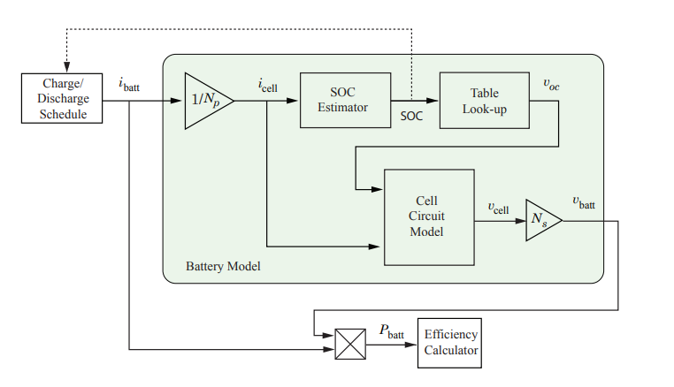

**Figure 1. Top-level Battery Model [1]**

**Table 1. Open-circuit Voltage versus State of Charge (SoC)**

|  |  |
| --- | --- |
| State of Charge (SoC) | Open-circuit Voltage, V |
| 0.00 | 3.51 |
| 0.10 | 3.57 |
| 0.25 | 3.63 |
| 0.50 | 3.71 |
| 0.75 | 3.93 |
| 0.90 | 4.08 |
| 1.00 | 4.19 |

Figure 2 shows the equivalent-circuit battery cell model. A positive current, , discharges the cell and negative current charges the cell. More definitions of the variables in the Figure are given in Table 2.

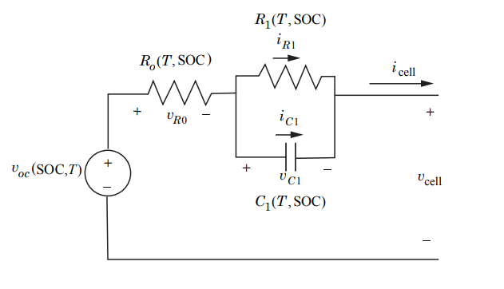

**Figure 2. Equivalent-circuit battery cell model**

**Table 2. Equivalent-circuit battery cell model variable definitions**

|  |  |
| --- | --- |
| Variable | Definition |
|  | Open-circuit voltage of Cell, V |
|  | Bulk resistance and solid electrolyte interface (SEI) layer impedance |
|  | Losses of Li-ions moving through the electrolyte |
|  | Current flowing through R1 |
|  | Capacitor current |
|  | Capacitor voltage |
|  | Transient response under load changes |
|  | Cell current |
|  | Cell voltage |
| T | Temperature |
| SoC | State of Charge |

Assume that the initial conditions are , , . Applying Kirchhoff’s voltage law, we have: . Applying Kirchhoff’s current law to the same circuit, we have: . The capacitor voltage is . Figure 3 shows this in the Simulink block diagram. The parameters of the cell at 40°C temperature is shown in Table 3. Effective cell capacity is assumed to be fixed and constant of 31 Ah. State of Charge (SoC) is estimated using a method called Coulomb counting method, as shown in Figure 3. Roundtrip efficiency is the ratio of discharge energy to charge energy. The roundtrip efficiency is estimated using a method called Efficiency method, as shown in Figure 4. Battery losses are calculated by subtracting discharge energy from charge energy.

**Table 3. Cell parameters at 40°C temperature**

|  |  |
| --- | --- |
| Variable | Value |
|  | 0.009 Ω |
|  | 0.0015 Ω |
|  | 3.5x104 F |

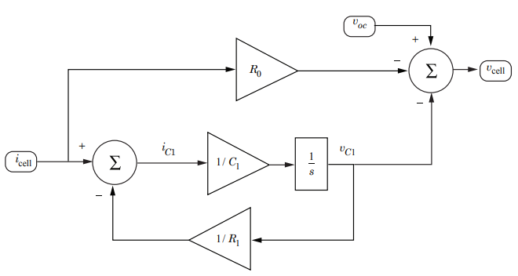

**Figure 3. Cell subsystem model**

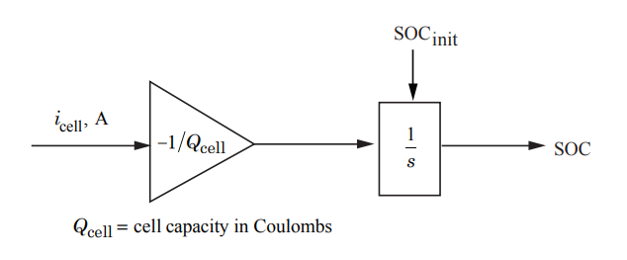

**Figure 4. SOC Calculation model**

**Simulation**

Assume that the battery consists of 6 parallel strings () of 100 series-connected cells () for a nominal battery voltage of 370V and battery capacity of 186 Ah. The following charge-discharge cycles will be studied:

1. *(Slow Charge and Slow Discharge):* Charge: , C-rate = 0.2 to . Discharge: C-rate = 0.2, to .
2. *(Fast Charge and Slow Discharge):* Charge: , C-rate = 2 to . Discharge: C-rate = 0.2, to .
3. *(Fast Charge and Fast Discharge):* Charge: , C-rate = 2 to . Discharge: C-rate = 2, to .
4. *(Fast Charge and Fast Discharge over short time interval):* Charge: , C-rate = 2 to . Discharge: C-rate = 2, to .

**Results and Discussion**

1. *(Slow Charge and Slow Discharge):* Charge: , C-rate = 0.2 to . Discharge: C-rate = 0.2, to .
   1. Plot of



**Figure 5. Battery voltage versus time**

Cell voltage starts out a bit lower than 370V and increases to about 425V during slow charging at 0.2 C-rate. There is a voltage drop from 425V to 412V due to 0.009 Ω. and determine the transient response of the discharge. The cell voltage passes the maximum voltage cutoff of 420V at time 12500 seconds while charging and drops below minimum of 370V while discharging at 22500 seconds. The reason for the increase is due to Lithium plating, where lithium accumulates over the surface of the anode. The reason for the decrease below cutoff is due to anode dissolving the copper current collector.

* 1. Plot of



**Figure 6. Battery current versus time**

The battery current in charging is negative, at about -37A until time of 15000 seconds when the current becomes positive, which means discharging at 37A. This is a slow charge and slow discharge at 0.2 C-rate.

* 1. Plot of



**Figure 7. Battery power versus time**

The power of the battery is negative and decreasing at -15 kW because it is charging until 15000 seconds. Then, the power of the battery becomes positive and decreases from 15 kW.

* 1. Plot of



**Figure 8. SOC versus time**

The SOC starts at 0.2 and increases to 1 until 15000 seconds. The SOC, then starts to decrease in the discharging phase back to 0.2.

* 1. Determine the net energy delivered to the load, the net losses (in kWh), and the round-trip efficiencies.

**Table 4. Net energy delivered to the load, net loses and efficiencies**

|  |  |
| --- | --- |
| Variable | Value |
|  | 58.03 kWh |
|  | 56.09 kWh |
| Net Energy | 1.94 kWh |
|  | 0.9666 |

1. *(Fast Charge and Slow Discharge):* Charge: , C-rate = 2 to . Discharge: C-rate = 0.2, to .
   1. Plot of



**Figure 9. Battery voltage versus time**

Cell voltage starts out a bit above 420 and increases to about 475V during fast charging at 2 C-rate. There is a voltage drop from 475V to 425V due to 0.009 Ω. and determine the transient response of the slow discharge. The cell voltage passes the maximum voltage cutoff of 420V at time 0 seconds while charging and drops below minimum of 370V while discharging at 8000 seconds. The reason for the increase is due to Lithium plating, where lithium accumulates over the surface of the anode. The reason for the decrease below cutoff is due to anode dissolving the copper current collector. To avoid going past maximum voltage, we should do trickle charging by changing the current instead.

* 1. Plot of



**Figure 10. Battery current versus time**

The battery current in charging is negative, at about -370A until time of 1700 seconds. That is when the capacity is reached, when the current becomes positive, which means discharging at 37A. This is a fast charge at 2 C-rate and slow discharge at 0.2 C-rate.

* 1. Plot of



**Figure 11. Battery power versus time**

The power of the battery is negative and decreasing at -150 kW because it is charging until 1700 seconds. Then, the power of the battery becomes positive and constant at 15 kW during discharging phase.

* 1. Plot of



**Figure 12. Battery SOC versus time**

The SOC starts at 0.2 and increases to 1 until 1700 seconds. The SOC, then starts to decrease in the discharging phase back to 0.2 until 16000 seconds.

* 1. Determine the net energy delivered to the load, the net losses (in kWh), and the round-trip efficiencies.

**Table 5. Net energy delivered to the load, net loses and efficiencies**

|  |  |
| --- | --- |
| Variable | Value |
|  | 66.75 kWh |
|  | 56.10 kWh |
| Net Energy | 10.65 kWh |
|  | 0.8404 |

1. *(Fast Charge and Fast Discharge):* Charge: , C-rate = 2 to . Discharge: C-rate = 2, to .
   1. Plot of



**Figure 13. Battery voltage versus time**

Cell voltage starts out a bit above 420 and increases to about 475V during fast charging at 2 C-rate. There is a voltage drop from 475V to 350V due to 0.009 Ω. and determine the transient response of the fast discharge of 2 C-rate. The cell voltage passes the maximum voltage cutoff of 420V at time 0 seconds while charging and drops below minimum of 370V while discharging at 1500 seconds. The reason for the increase is due to Lithium plating, where lithium accumulates over the surface of the anode. The reason for the decrease below cutoff is due to anode dissolving the copper current collector. To avoid going past maximum voltage, we should do trickle charging by changing the current instead.

* 1. Plot of



**Figure 14. Battery currently versus time**

The battery current in charging is negative, at about -370A until time of 1700 seconds. That is when the capacity is reached, when the current becomes positive, which means discharging at 370A. This is a fast charge at 2 C-rate and slow discharge at 2 C-rate.

* 1. Plot of



**Figure 15. Battery power versus time**

The power of the battery is negative and decreasing at -150 kW because it is charging until 1700 seconds. Then, the power of the battery becomes positive and decreases from 150 kW during discharging.

* 1. Plot of

**Figure 16. Battery SOC versus time**

The SOC starts at 0.2 and increases to 1 until 1700 seconds. The SOC, then starts to decrease in the discharging phase back to 0.2 until 2800 seconds.

* 1. Determine the net energy delivered to the load, the net losses (in kWh), and the round-trip efficiencies

**Table 6. Net energy delivered to the load, net loses and efficiencies**

|  |  |
| --- | --- |
| Variable | Value |
|  | 66.75 kWh |
|  | 47.47 kWh |
| Net Energy | 19.28 kWh |
|  | 0.7113 |

1. *(Fast Charge and Fast Discharge over short time interval):* Charge: , C-rate = 2 to . Discharge: C-rate = 2, to .
   1. Plot of



**Figure 17. Battery voltage versus time**

Cell voltage starts out a bit above 430 and increases to about 440V during fast charging at 2 C-rate. There is a voltage drop from 440V to 325V due to 0.009 Ω. and determine the transient response of the fast discharge of 2 C-rate. The cell voltage passes the maximum voltage cutoff of 420V at time 0 seconds while charging and drops below minimum of 370V while discharging at 90 seconds. The reason for the increase is due to Lithium plating, where lithium accumulates over the surface of the anode. The reason for the decrease below cutoff is due to anode dissolving the copper current collector. To avoid going past maximum voltage, we should do trickle charging by changing the current instead.

* 1. Plot of



**Figure 18. Battery current versus time**

The battery current in charging is negative, at about -370A until time of 90 seconds. That is when the capacity is reached, when the current becomes positive, which means discharging at 370A. This is a fast charge at 2 C-rate and slow discharge at 2 C-rate.

* 1. Plot of



**Figure 19. Battery power versus time**

The power of the battery is negative at -160 kW because it is charging until 1700 seconds. Then, the power of the battery becomes positive and decreases from 130 kW during discharging.

* 1. Plot of



**Figure 20. Battery SOC versus time**

The SOC starts at 0.5 and increases to 0.55 until 90 seconds. The SOC, then starts to decrease in the discharging phase back to 0.5 until 180 seconds.

* 1. Determine the net energy delivered to the load, the net losses (in kWh), and the round-trip efficiencies.

**Table 7. Net energy delivered to the load, net loses and efficiencies**

|  |  |
| --- | --- |
| Variable | Value |
|  | 4.076 kWh |
|  | 2.948 kWh |
| Net Energy | 1.128 kWh |
|  | 0.7232 |

**Bonus**

Travel time in hours using the US06 cycle continuously until SOC reaches 0.2 from 1.0 is equal to 3.9 hours. The distance traveled is calculated from US06 cycle to be 202 miles.

**Table 8. Net energy delivered to the load, net loses and efficiencies**

|  |  |
| --- | --- |
| Variable | Value |
|  | 15.51 kWh |
|  | 69.16 kWh |
| Net Energy | 53.65 kWh |
|  | 58.03 kWh |
|  | 66.75 kWh |



**Figure 21. Battery voltage versus time**

The voltage of the battery starts at 440V and fluctuates and decreases with time to 320V. The fluctuations represent the times when the vehicle is decelerating, where the batteries are being recharged.



**Figure 22. Battery current versus time**

The current of the battery starts out negative and fluctuates to positive, meaning it is getting charged and discharged as the vehicle is traveling. It fluctuates from -150A to 300A.



**Figure 23. Battery power versus time**

The battery power also fluctuates, and it fluctuates from -60kW to 100kW.



**Figure 24. SOC versus time**

The State of Charge decreases with time. There are a couple of time when the SOC is going up because of regenerative braking.

**Appendix**

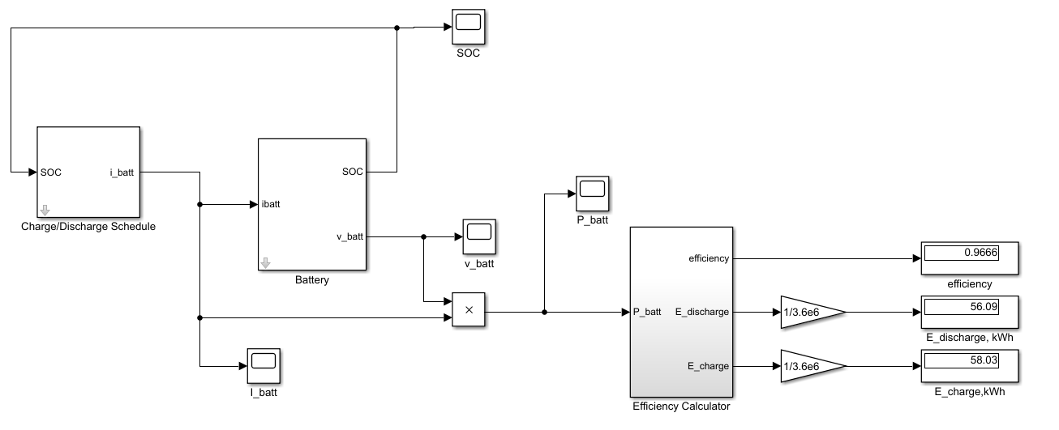

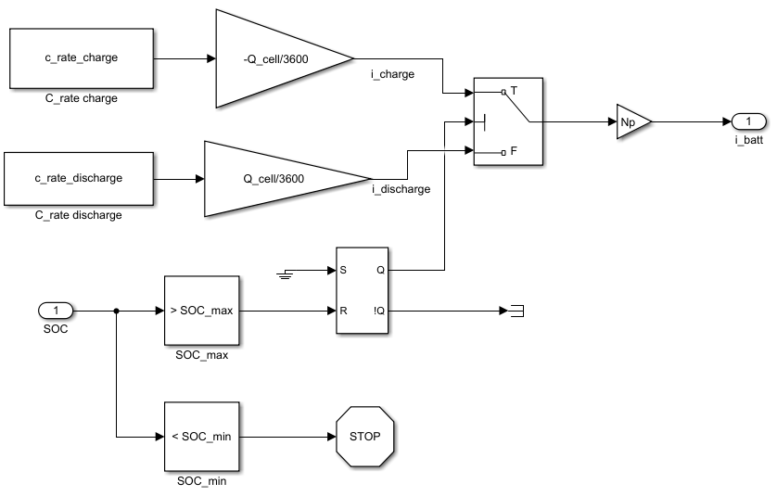

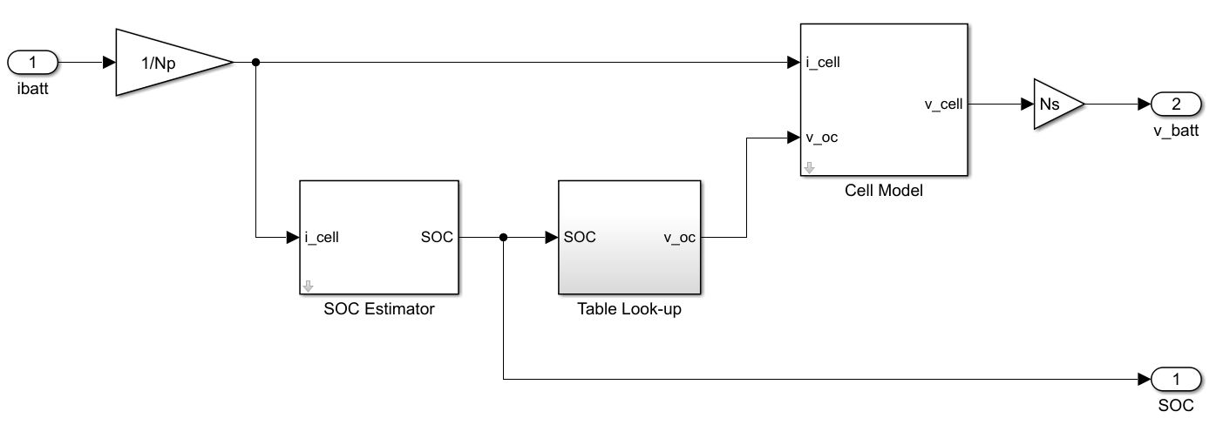

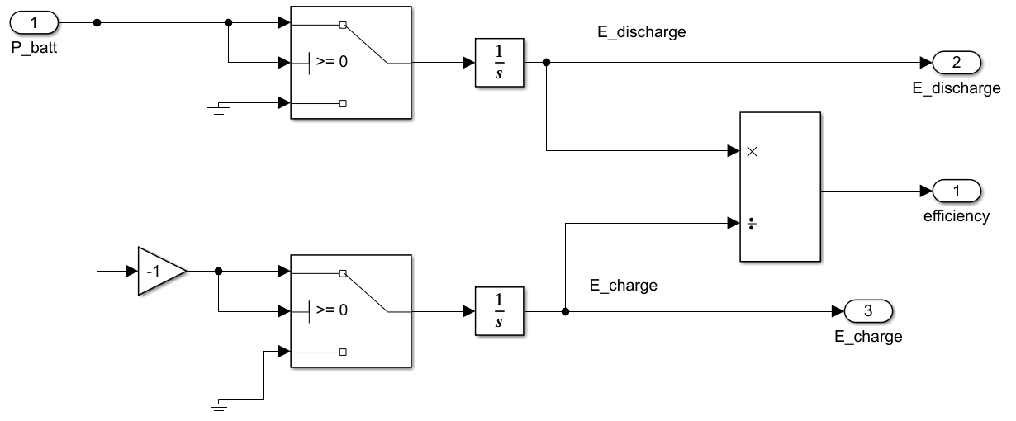

**Bonus:**

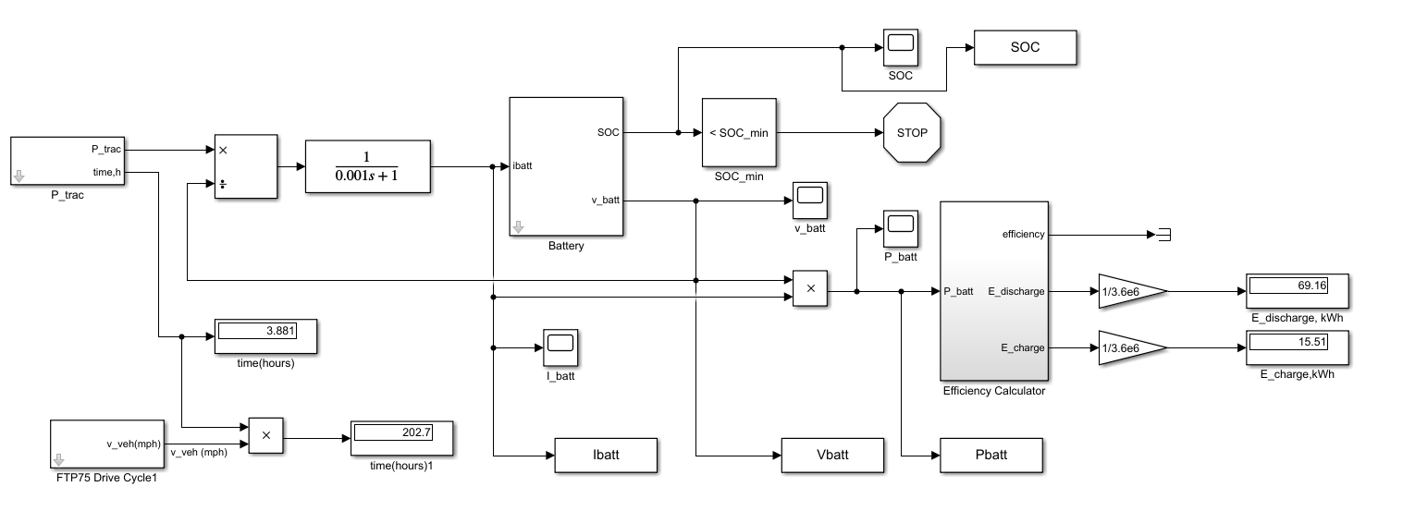

figure(1)

x = Vbatt.time;

y = Vbatt.signals.values;

plot(x,y)

grid on

title('V_{batt} versus time')

ylabel('V_{batt} (V)')

xlabel('time (s)')

figure(2)

x = Pbatt.time;

y = Pbatt.signals.values/1000;

plot(x,y)

grid on

title('P_{batt} versus time')

ylabel('P_{batt} (kW)')

xlabel('time (s)')

figure(3)

x = Ibatt.time;

y = Ibatt.signals.values;

plot(x,y)

grid on

title('I_{batt} versus time')

ylabel('I_{batt} (A)')

xlabel('time (s)')

figure(4)

x = SOC.time;

y = SOC.signals.values;

plot(x,y)

grid on

title('SOC versus time')

ylabel('SOC')

xlabel('time (s)')

figure(5)

x = Ebatt.time;

y = Ebatt.signals.values/1000/3600;

plot(x,y)

grid on

title('E_{batt} versus time')

ylabel('E_{batt} (kWh)')

xlabel('time (s)')

clearvars;

load us06.txt

% Cell capacity

Capacity = 31; % Ampere-hours

Q_cell = Capacity*3600; % cell capacity in Coulombs

% R0 resistance

R0 = 0.009;

% R1 Resistance

R1 = 0.0015; %Ohms

% C1 Capacitance

C1 = 3.5e4; %Farads

Ns = 100; % Number of series cells

Np = 6; % Number of parallel cells

load P_trac.mat

SOC_min = 0.2;